Conceptual System Architecture Diagram of a Malware Remediation Program
Introduction
The architecture diagram provides a diagrammatic representation that helps conceptually define the view, structure, and behaviour of the program. It defines the system’s core components, external entities, and interactions. The goal of the diagram is to present a clear and intuitive picture of how the system operates and how data flows between the different components. The architecture aims to remain conceptually simple and avoids in-depth implementation details.

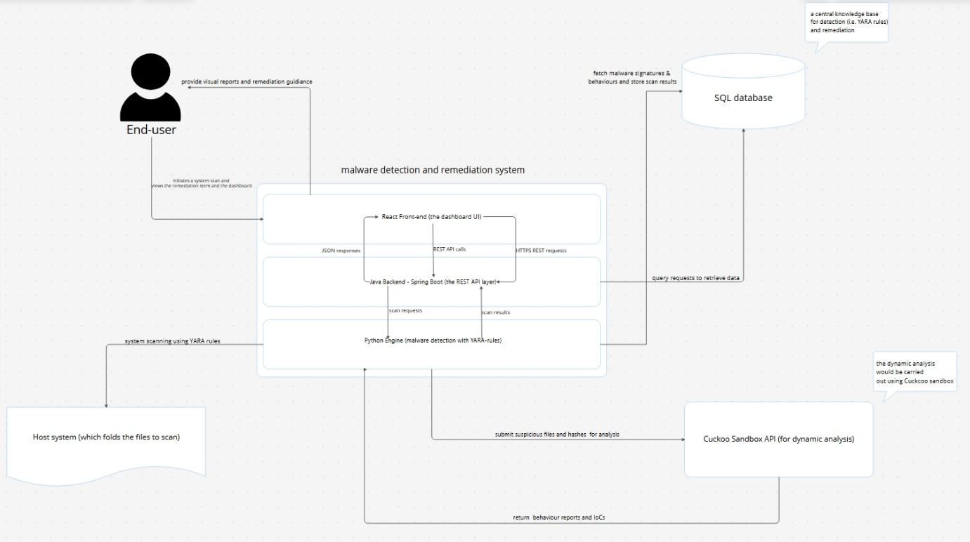

Core System
At the centre of the architecture is the Malware Detection & Remediation System. It is represented as a single core system with three internal components arranged vertically:
- React Front-End (with a dashboard User Interface)
  - It provides an interactive dashboard for users to initiate scans, view results, and access remediation guidance.
- Java Backend (Spring Boot REST API Layer)
  - It exposes REST APIs for the front-end, orchestrates scan requests, communicates with the Python engine, and interacts with the database to serve data to the UI.
- Python Engine (Malware Detection Engine)
  - It performs malware detection using YARA rules and pattern matching. It reads malware signatures and behaviours from the SQL database, writes scan results back to the database, and integrates with the Cuckoo Sandbox API to perform dynamic analysis on suspicious samples.

External Entities
The core system interacts with four external entities, which are represented outside the central core, they include:
- End User (e.g. a security analyst)
  - They interact with the system through the React front-end.
- Host System
  - It represents the machine and files stored on the machine which are being scanned by the Python engine.
- SQL Database
  - It stores malware information like behaviour patterns, malware signatures, and remediation steps.
- Cuckoo Sandbox API
  - It provides dynamic behavioural analysis for suspicious files or hashes, which are submitted by the Python engine.

Interactions and Data Flows
Interaction between system components and external entities is represented through directional arrows:
- User React Front-End
  - An end user initiates scans, retrieves remediation data, and views visual reports and alerts.
- React Front-End ↔ Java Backend (Spring Boot)
  - The REST API calls carry scan requests and fetch scan history and results as JSON responses.
- Java Backend ↔ Python Engine
  - The backend sends scan jobs, file paths, and YARA-related instructions, while the engine returns detection outcomes, and status information.
- Python Engine ↔ SQL Database
  - The engine retrieves malware signatures, behaviours, and remediation steps, and writes scan logs and results.
- Java Backend ↔ SQL Database
  - The backend queries scan histories and remediation information to be used for reporting and presentation on the UI dashboard.
- Python Engine ↔ Host System / File System
  - It performs file system scanning operations using YARA rules.
- Python Engine ↔ Cuckoo Sandbox API
  - It submits suspicious samples or hashes for in-depth sandbox analysis and receives behavioural indicators and IOCs used to enrich detections and remediation recommendations.

Conclusion
The React front-end offers a single point of interaction for end users through an interactive dashboard.
The SQL database serves as a central knowledge base for malware signatures, behaviour patterns, remediation steps, and scan logs.
The combination of static analysis (via YARA rules) and dynamic analysis (via Cuckoo Sandbox API) allows the system to enhance detection outcomes and remediation guidance without exposing unnecessary implementation details at this conceptual level.

